2.3 I can use a range of tools and techniques in the recommended way.

Gantt chart for marking assessing our work

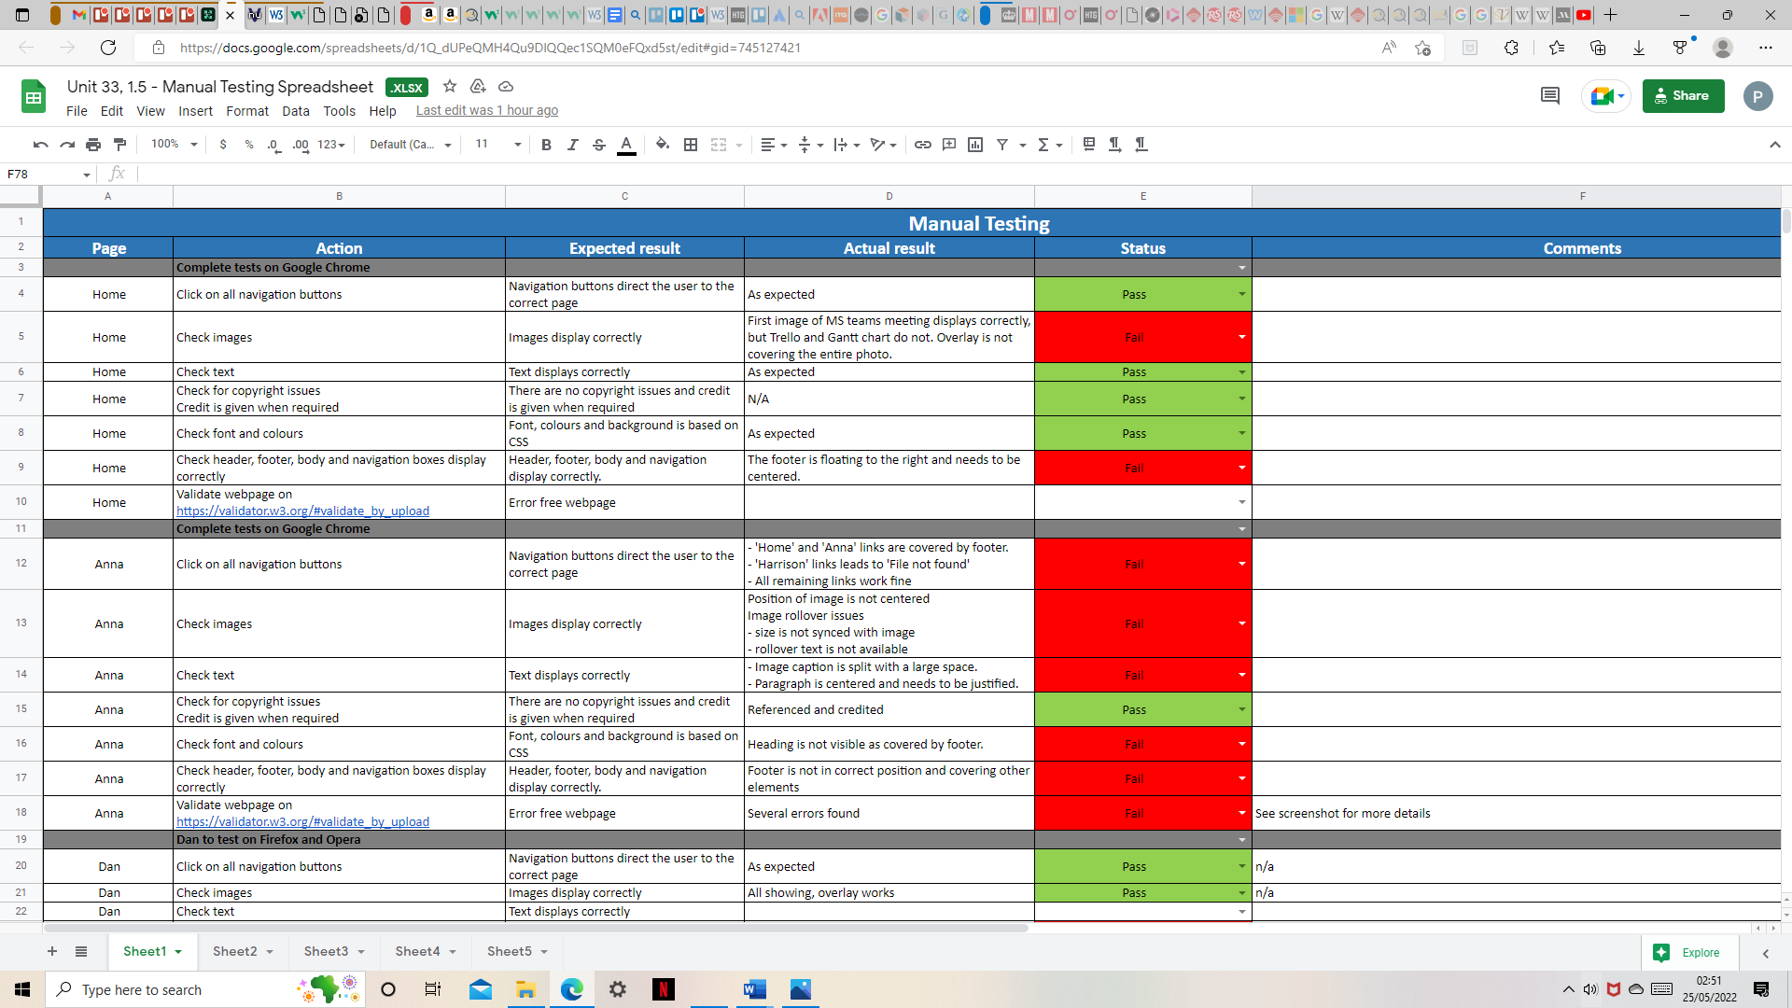

Kanban for discussing what we should do as a collaborative group

